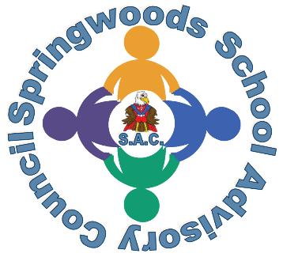
Springwoods School Advisory Council (SAC)
Former Parent Advisory Council (PAC)

Meeting Agenda
December 4th, 2024
6pm Virtual via Zoom

- Welcome (-1 Min)
- Budget Updates (-10 Mins)
- Updates on School Improvement Plan (-10 Mins)
  - Fostering Parent/Teacher Collaboration to Assist in Improving Reading and Math Performance
    - Homework and Materials (Daniela) (-5 Mins)
- SACI Report (Duncan and Kate) (-5 Mins)
- Hot Topics (Mr. Harkins?)
  - VALLS SACI (Kate) ??? -(5 Mins)
    - Progress on Steps to Success/Tutoring etc (Mr. Harkins?)(-5 Mins)
- Progress on Bylaws (3 mins)
- Open Forum (5 mins)
- Plans for next meeting
- Adjournment

