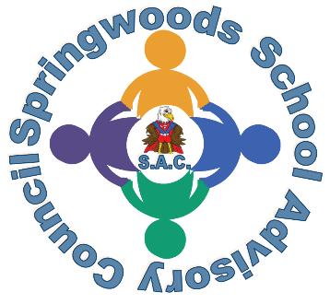
Springwoods School Advisory Council (SAC)
Former Parent Advisory Council (PAC)

Meeting Agenda
March 15, 2023
7.30pm Virtual via Zoom

- Welcome & New Logo (1 min)
- Hot Topics (~ 5mins) – hot topics will also be shared with PTA (prior meeting)
- Budget updates (~ 5mins)
- Updates on Improvement plan (~25-30 mins)
- Discuss progress of PAC visibility and Parent Involvement Survey Draft (~5-10mins)
- Open Forum (5mins)
- Possible agenda items for next meeting (~ 3mins)
- Adjournment

